How to Make Power Source for Lab 7&8 Created By Zhe Chu in Mar/30

1. Before you start the process, you need to prepare the following materials:
2. 4 * AA 1.2V batteries
3. Wires
4. Tape and scissor

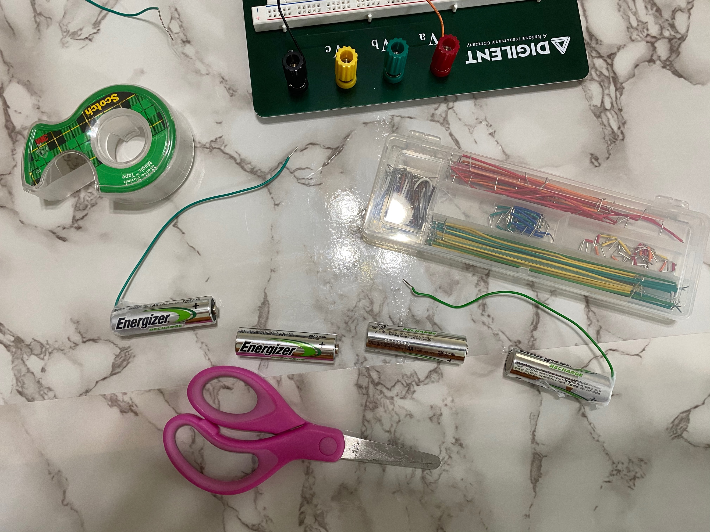

Figure 1. Materials Needed for the Lab.

1. Understanding what’s the simple circuit you are trying to create:

An AA battery is a simple 1.2 V DC power source. However, what we want to have is a power source which can provide approximately 4.7V voltage. To quadruple the voltage of our power source, we can simply connect 4 AA batteries in series. This implement simple circuit theorem. All you need to remember is connect power source in series will increase voltage can be provided. The following figure shows the draft circuit of power source we are trying to build.

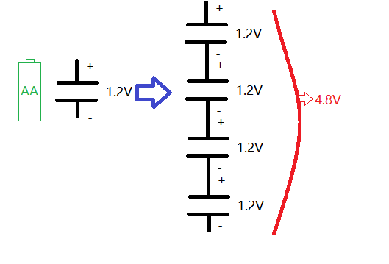

Figure 2. Power Source Circuit Draft.

1. The figure 3 in below shows the final looks of your power source. To make such a power source, you need to use wires to connect + end of a battery to the – end of another battery. Figure 4 and 5 shows how can we use tape to fix wires.

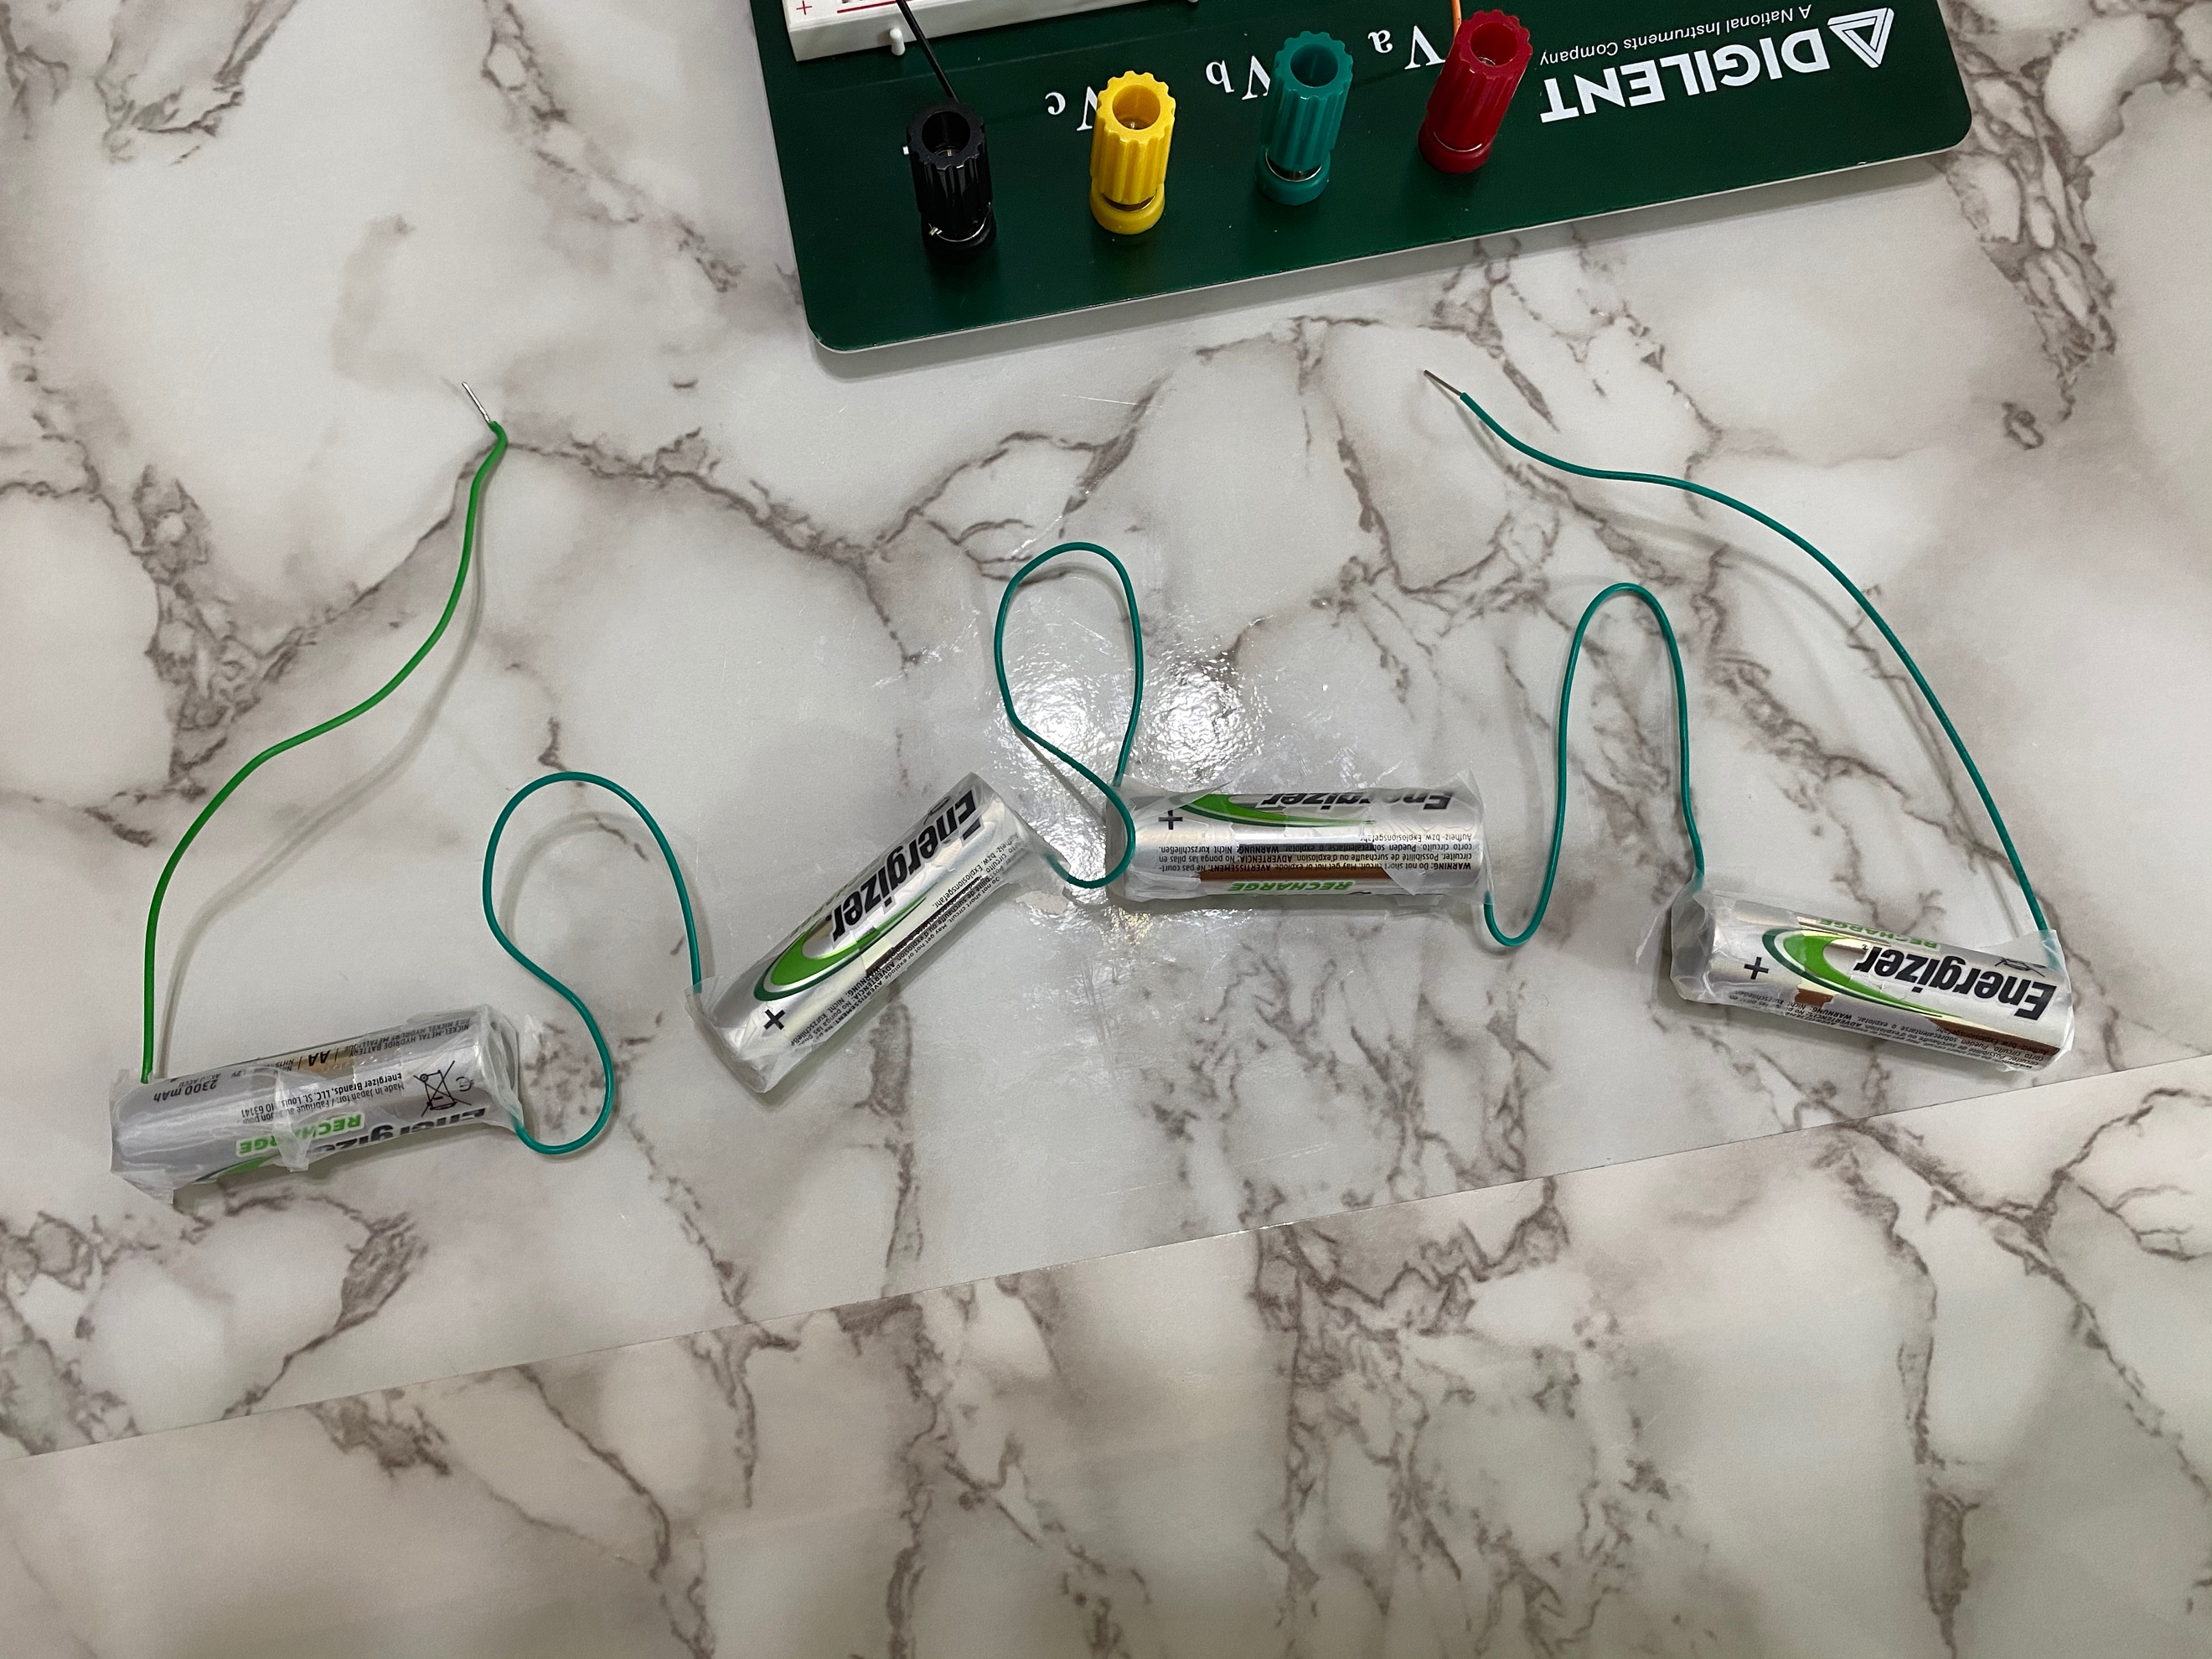

**-**

**-**

**-**

**-**

**+**

**+**

**+**

**+**

Figure 3. Final Power Sources Preview.

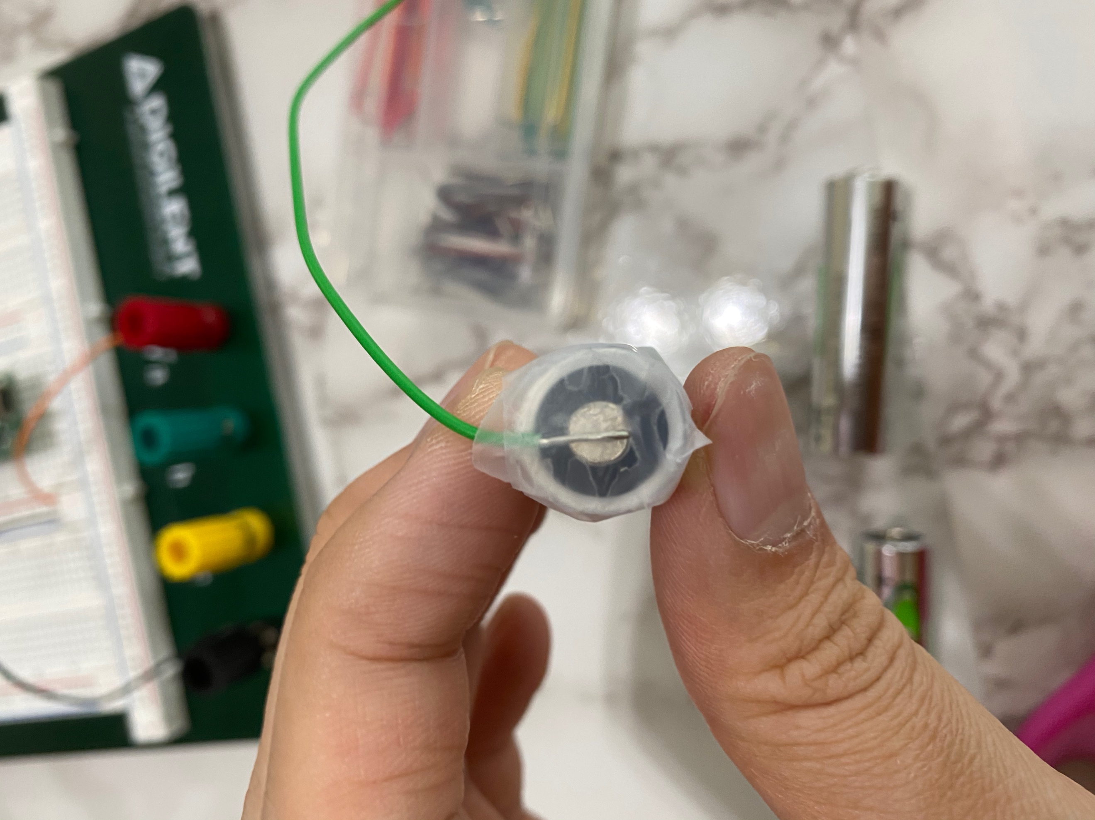

Figure 4. Fix Wire On + End.

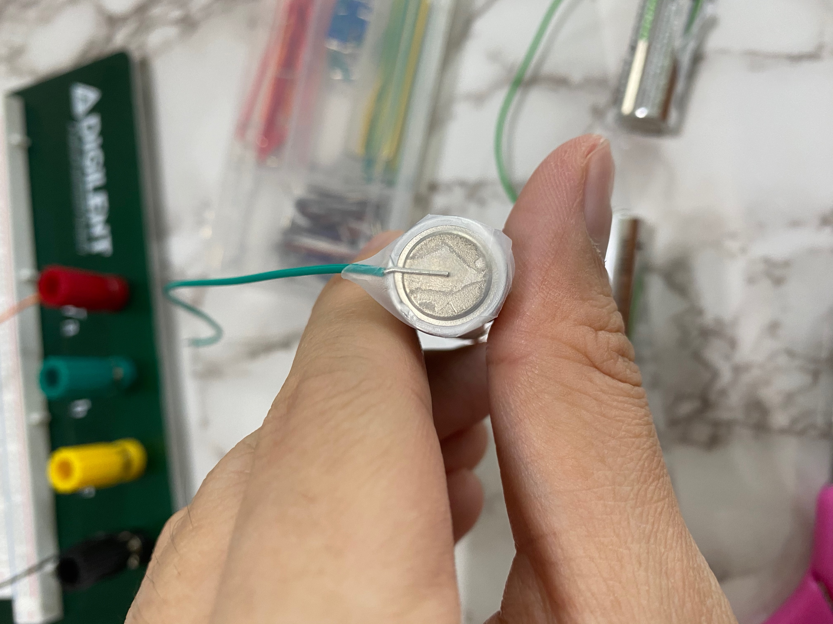

Figure 5. Fix Wire On - End.

1. Now, you are ready to connect your power source to the circuit. A successful build of power source will make all pixels on LCD monitor show blacks. Figure 6 shows the LCD display after you successfully build and connect your power source. However, this is not the end of the story, please take a look on step 5.

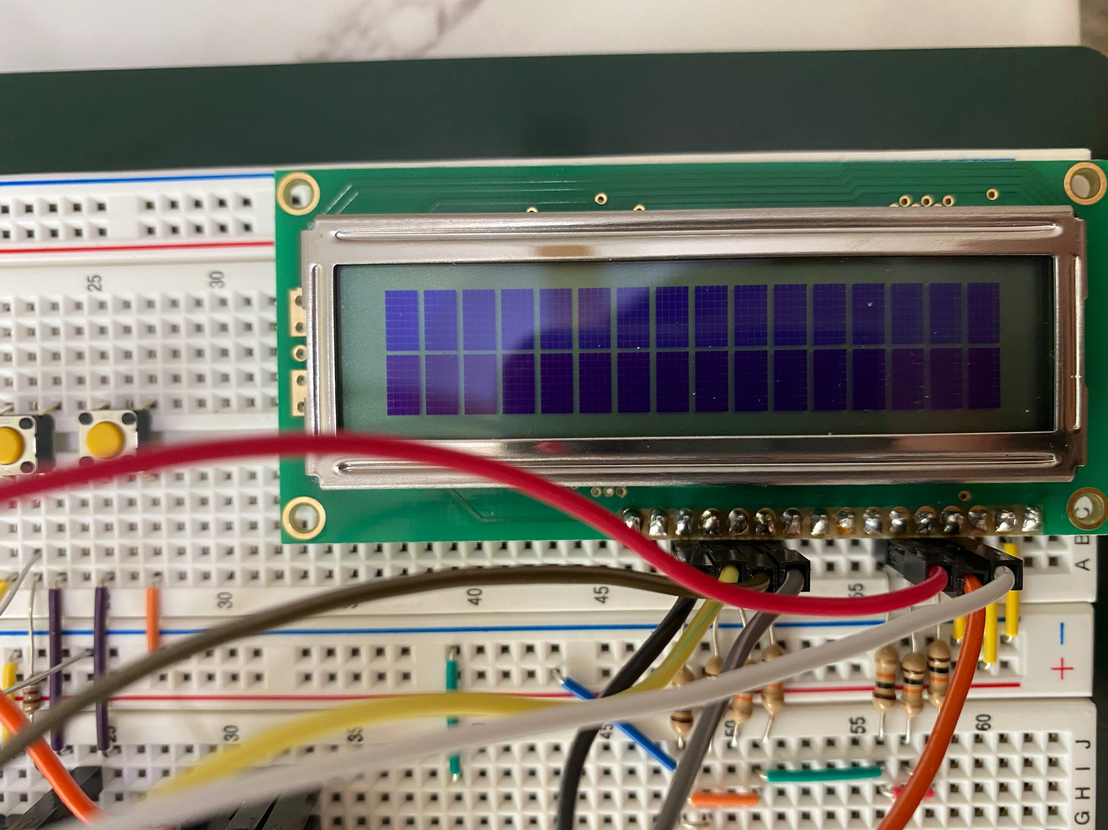

Figure 6. A Glance at LCD Monitor After Successfully Build and Connect Power Source.

1. The power source you created is 4.8 V, which is slightly higher than what we want to have for the labs. It can’t give you a crystal-clear view of the words show on the screen. The best way to view something on the screen and record them is to view your screen with a sharp angle. Figure 7 shows what you should be able to see after you run your program.

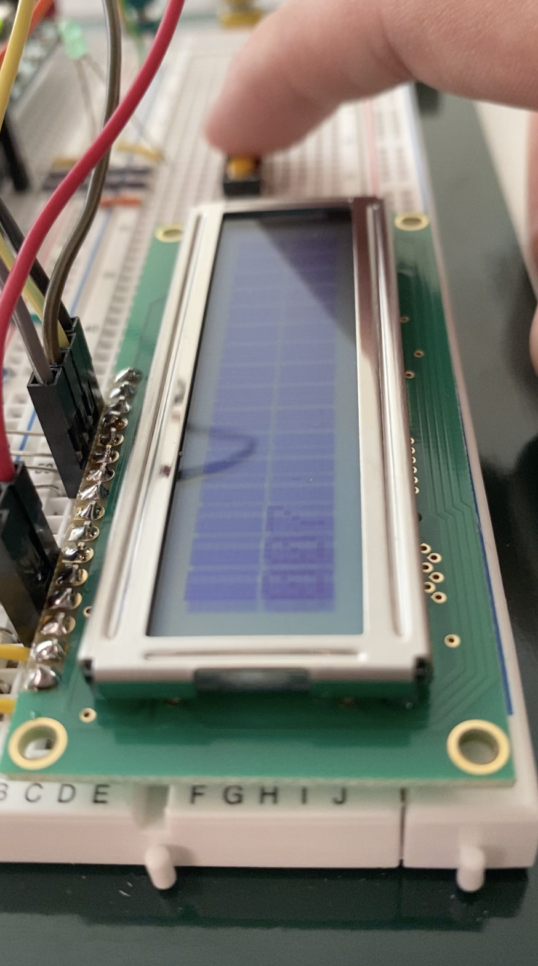

Figure 7. View your LCD Display with a Sharp Angle.